
Dashboard Design

Date | 22 September 2026
Team ID | MCA
Project Name | Strategic Employee Attrition Intelligence Dashboard
Maximum Marks | 5 Marks

Creating an effective dashboard involves thoughtful design to ensure that the presented information is clear, relevant, and easily understandable for the intended audience. Here are some key principles and best practices for dashboard design
Activity 1: Interactive and visually appealing dashboards
Creating interactive and visually appealing dashboards involves a combination of thoughtful design, effective use of visual elements, and the incorporation of interactive features. Here are some tips to help you design dashboards that are both visually appealing and engaging for users so take care of below points
- Clear and Intuitive Layout
- Use Appropriate Visualizations
- Colour and Theming
- Interactive Filters and Slicers
- Drill-Down Capabilities
- Responsive Design
- Custom Visuals and Icons
- Use of Infographics
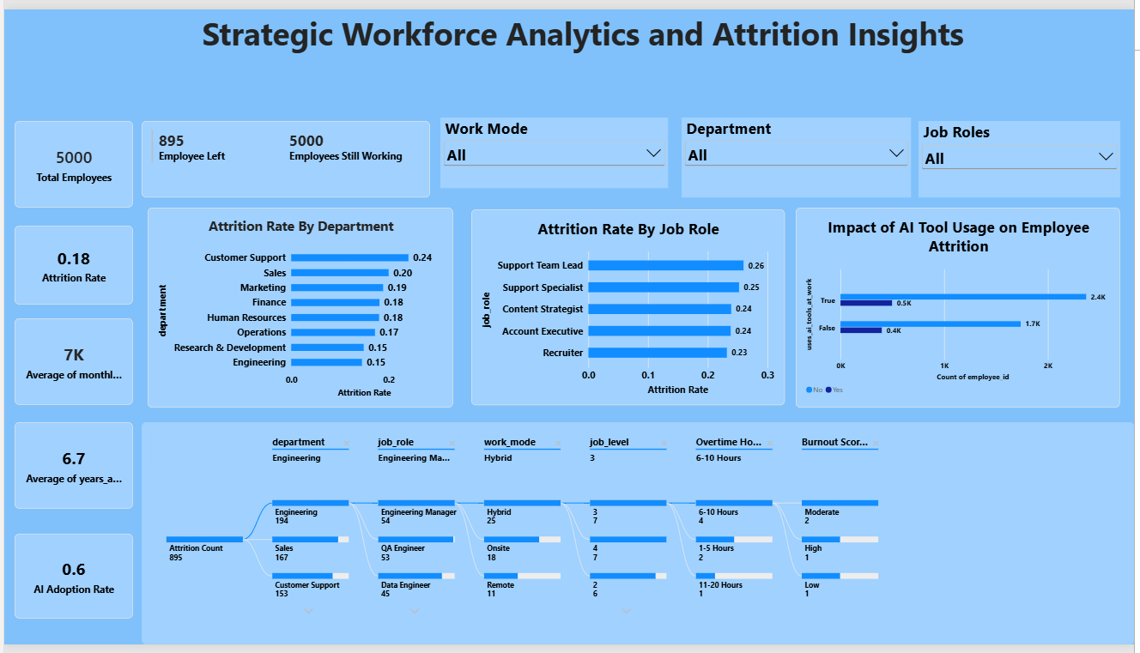
Major Outcomes from the Dashboard
Here are five major outcomes from the Strategic Workforce Analytics and Attrition Insights dashboard:
- Employee Attrition: The dashboard shows 5,000 total employees and 895 employees who left, with an overall attrition rate of approximately 18%.
- Department-wise Attrition: Customer Support has the highest attrition rate at 24%, followed by Sales at 20% and Marketing at 19%. Engineering and Research & Development show comparatively lower rates of 15%.
- Job Role-wise Attrition: Among the displayed job roles, Support Team Lead has the highest attrition rate at 26%, followed by Support Specialist at 25%. Recruiter has an attrition rate of 23%.
- AI Tool Usage and Attrition: The AI tool usage visualization shows employee counts separated by AI usage status. Among employees marked True, approximately 2.4K are in the “No” category and 0.5K in the “Yes” category; among those marked False, approximately 1.7K are “No” and 0.4K are “Yes”.
- Employee Characteristics and Attrition: The dashboard provides additional segmentation through department, job role, work mode, job level, overtime hours, and burnout score. The displayed selection highlights Engineering (194 attrition cases), followed by Sales (167) and Customer Support (135), allowing HR to examine specific employee segments associated with attrition.

